# Unix Bash Assignment

**\*Note:** All the Assignments in the PDF are executed using **WSL2** using **vi editor,** and all the file used to complete the Assignment is Given Below

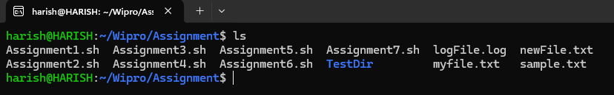

**Assignment 1:** Ensure the script checks if a specific file (e.g., myfile.txt) exists in the current directory. If it exists, print "File exists", otherwise print "File not found"

**Step 1:**

Create a Shell Script file for of any name starting with **vi** with the extension of ".sh"

**Syntax: vi filename.sh**

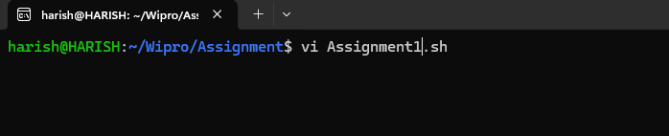

**Step 2:**

The above code will open the **vi editor** in the editor write the code in Bash shell scripting language.

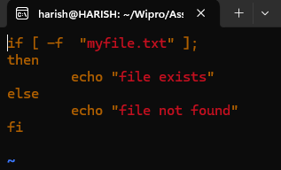

The above code is a simple if loop to check if the file exists in the current directory or not. "-f" will return true if file exists.

**Step 3:**

After writing code close the vi editor by press esc, then ":wq: to save and quit to the cmd

**Step 4:**

To Execute the code use bash filename. And the output will be shown below

**Syntax: bash filename.sh**

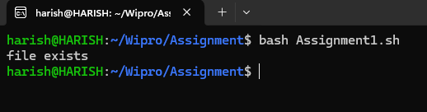

**Assignment 2:** Write a script that reads numbers from the user until they enter '0'. The script should also print whether each number is odd or even.

**Answer:**

To take input from the user "read" cmd is used

**Program:**

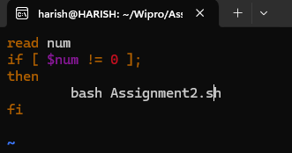

Here we use recursion to call the same function until the user gives input as "0".

**Output:**

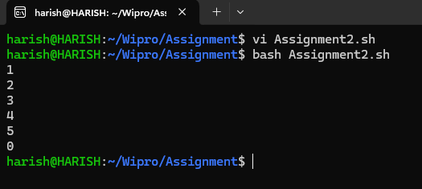

**Assignment 3:** Create a function that takes a filename as an argument and prints the number of lines in the file. Call this function from your script with different filenames.

**Answer:**

To return the number of lines in a code we use "wc" and the file name of which we want to know the number of lines

**Syntax: wc -l filename**

This will return number of lines and file name

If we don’t want the file name then we append < file name at the end.

**Syntax: wc -l < filename**

**Program:**

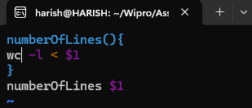

**Output:**

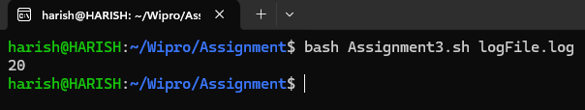

Here logFile.log is the file name passing as command line arguments, as it returned 20 which is 20 lines in it.

**Assignment 4:** Write a script that creates a directory named TestDir and inside it, creates ten files named File1.txt, File2.txt, ... File10.txt. Each file should contain its filename as its content (e.g., File1.txt contains "File1.txt").

**Answer:**

To create a new Directory we use **"mkdir"** followed by directory name

And to create new file with default text we use the following syntax

**Syntax: "Text” > filename.txt**

**Program:**

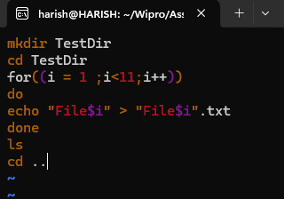

**Output:**

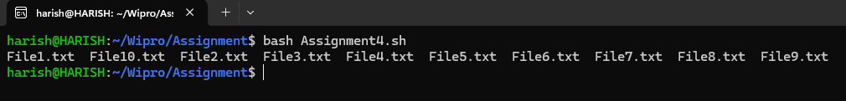

The above program creates a directory and in the directory we use for loop to traverse 10 times and creates files 10 times. And **"ls"** cmd to print all the file in the directory. And comes back using "**cd ..".**

**Assignment 5:** Modify the script to handle errors, such as the directory already existing or lacking permissions to create files.

Add a debugging mode that prints additional information when enabled**.**

**Answer:**

The previous assignment executes only once because a directory can’t be created again with the same name.

So to rectify that we use -d to check if the file exists or not

**Program:**

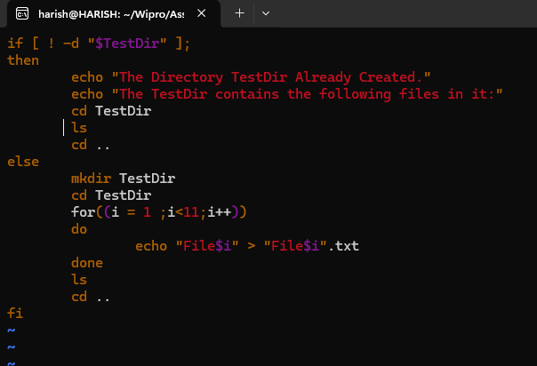

**Output:**

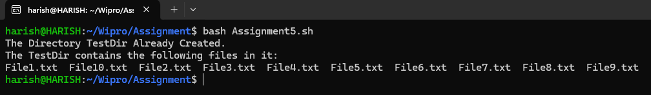

**Assignment 6:** Given a sample log file, write a script using grep to extract all lines containing "ERROR". Use awk to print the date, time, and error message of each extracted line.

**Answer:**

**Grep** is a command used for searching and manipulating text in a file

**Awk** is a programming language used for manipulating text in a file.

**logFile:**

To perform grep and awk operation we create a sample log file with some content in it.

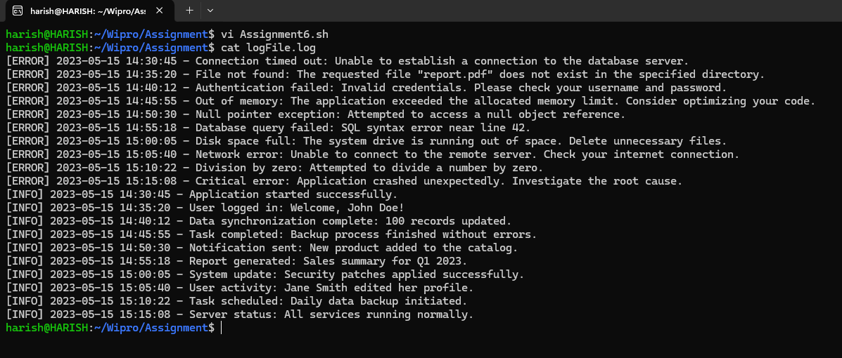

**Program:**

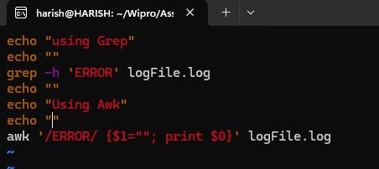

**Syntax for Grep: grep -h 'WORD' filename**

**Syntax for Awk: awk '/word/ {print $column number**

Here $1 is to make 1st column null and $0 is to print whole line

**Output:**

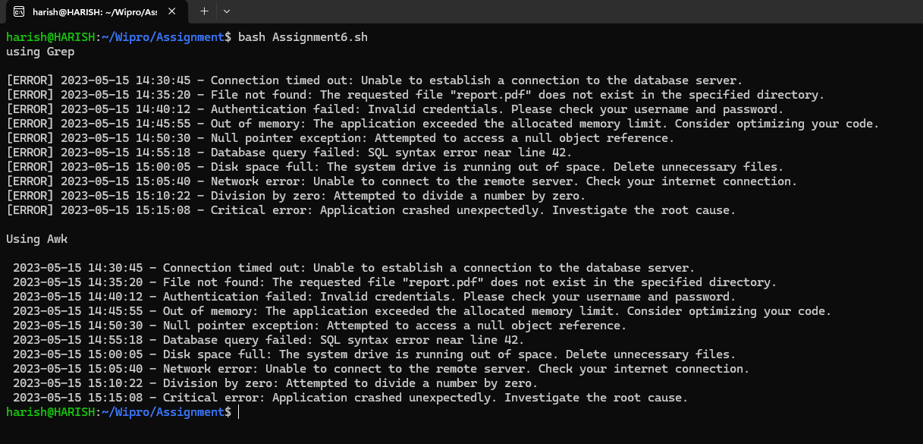

In the above output using grep we displayed the whole line in which ERROR is present

And using Awk we displayed the date and time and the error message without the word Error in it.

**Assignment 7:** Create a script that takes a text file and replaces all occurrences of "old_text" with "new_text". Use sed to perform this operation and output the result to a new file.

**Answer:**

**Sed** is a command stands for **Streaming Editor** and it can perform many functions like searching, find and replace, insertion and deletion. In this program we will replace old text with new one.

**Syntax: sed 's/old_text/new_text' filename**

**Program:**

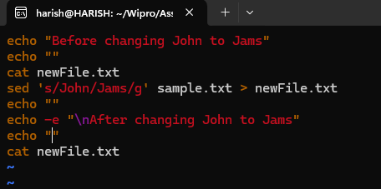

**Output:**

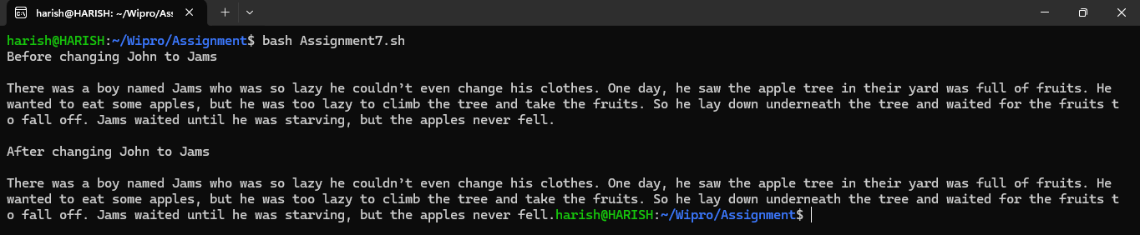

In the above output the name John is replaced with Jams.